**LABELS & SELECTOR**

--Provides a way to categorize & target resources within cluster

--Labels categorize resources in Kubernetes with identifying tags

--selectors filter resources based on their assigned labels

Example:

-If I am creating service, i will attach service to the deployment using labels.

-selectors are filters used to query and select Kubernetes resources based on the labels

syntax

Labels Selector

apiVersion: v1 apiVersion: v1

kind: Pod kind: Pod

metadata: metadata:

name: my-labels spec:

labels: selector:

app: my-nginx app: my-nginx

**Commands for labels and selector**

*Show all pods with labels

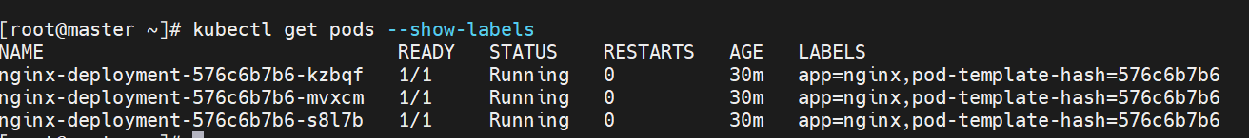



**Add new label to existing deployment**

**Syntax:**



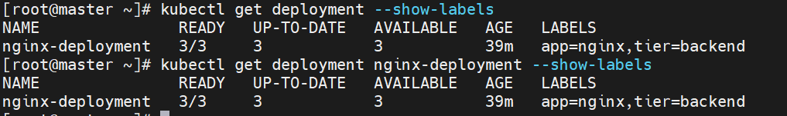

**Check the pods with label name**

**Syntax:**

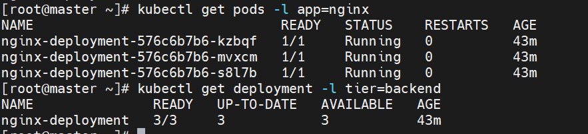

**Remove the label:**

**Syntax:**

